IAHC Journal Club Presentation for May 9 & 16, 2023.
Karen White-Trevino, Angela Blackburn, and Veronica Rosa
Picture and Bio

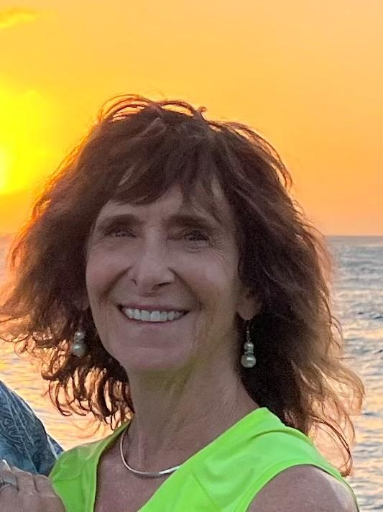

Biography: Dr. White-Trevino DNP, RN, NE-BC is an Assistant Professor of Clinical Practice at the University of West Florida and began teaching in higher education in the Fall of 2018. She teaches remotely from Kauai, Hawaii, and is also a lecturer at the University of Hawaii, Manoa. She has 40 years of nursing experience, primarily in the acute care setting and in various nursing leadership positions. Most notably, she held a hospital Chief Nursing Officer role in Pensacola, Florida from 2011-2018. She maintains a Nurse Executive certification from American Nurses Credentialing Center (ANCC), has extensive training in Watson’s Human Caring Theory, is a Caritas Coach®, and is a registered yoga teacher (RYT-200). She is passionate about mentoring nurse leaders by sharing her expertise and creative ways to promote health and wellness.
Dr. White-Trevino’s national appointments include being a faculty member in the Sigma Theta Tau International (Sigma) Nursing Leadership Academy for Clinical Practice from 2018-2021 and being a Commissioner for ANCC Pathway to Excellence 2020-2024, representing Academia. She is the current president of Sigma’s Upsilon Kappa Chapter, is on multiple committees for the International Association for Human Caring, and is a Red Cross volunteer in Kauai.

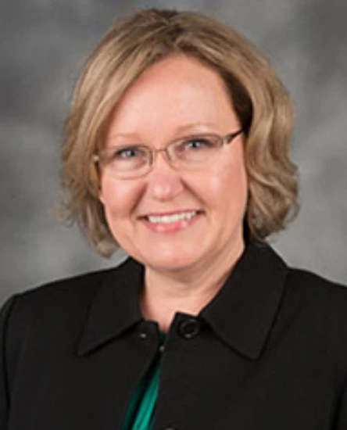

Biography:
Angela Blackburn, Ph.D., APRN, NNP-BC, Associate Professor is a nurse educator with more than 15 years experience in higher education. Before joining UWF in 2011, she taught at the University of South Alabama in the neonatal nurse practitioner program. She teaches Foundations of Nursing Science, Advanced Pharmacology, Population Health, Evidence-Based Practice and Advanced Pathophysiology. She is a HeartMath® Certified Trainer.
Dr. Blackburn earned a Ph.D. in Nursing (Ethics Specialization) from the University of Southern Mississippi. Her doctoral dissertation explored mothers’ stories of their neonatal intensive care unit experience using narrative research methods. She earned a BSN in nursing and MSN (Neonatal Nurse Practitioner) from the University of South Alabama. Dr. Blackburn holds national certification as a neonatal nurse practitioner. She has more than 25 years of clinical experience in health care settings.
Her area of research interest includes caring science, work site wellness, ethics, and qualitative research methods. She is an International Institute of Qualitative Methodology Member Scholar. She completed the Caritas Coach Education Program® (CCEP) offered by the Watson Caring Science Institute (WCSI) to advance the philosophies, theories, and educational-clinical-research practices of Caring Science in 2021. Dr. Blackburn was selected as a 2022-2023 Watson Caring Science Postdoctoral/Senior Scholar, where she will participate in a one year exclusive personal study with Dr. Jean Watson to expand knowledge of Caring Science as Sacred Science.
Dr. Blackburn has served in a variety of leadership roles including Interim Chairperson for the School of Nursing (2018-2020) graduate program director (2011-2018). She serves on the Ascension Gulf Coast Ethics Integration Committee, and the University of West Florida Institutional Review Board (2020-2022 chairperson). She is a board member of Sigma Theta Tau International Honor Society of Nursing, Upsilon Kappa Chapter.

Biography:
Veronica Rosa, MHA, BA, Admissions Coordinator at Road to Recovery, working with Lakeview Center (a division of Lifeview Group) for 8 years. She has previously worked as a counselor for Lakeview’s methadone clinic and as a case manager for Lakeview’s outpatient psychiatry.
Veronica received her certificate in management development, an undergraduate degree in psychology, and a Master of Healthcare Administration from the University of West Florida (UWF). She was a graduate assistant in the UWF School of Nursing. She also assisted with the research for analyzing healthcare cost associations of patients who use illicit drugs in Florida. Her work was published in September 2020 in the Journal of Substance Abuse Treatment, Prevention, and Policy.

